1. Login to Azure and connect to your AKS cluster.

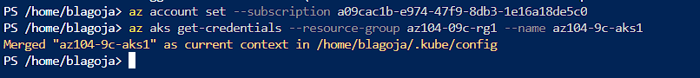

1. Check how many pods run under the default namespace. Run kubectl get pods.

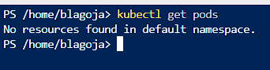

1. You should not see any pod under the default namespace. Now check all namespaces. Run kubectl get pods
   1. –all-namespace.

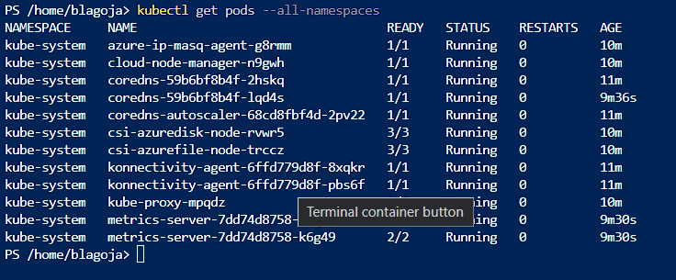

1. How many pods do you see? Who deployed these pods? Why are they deployed?
   1. There are 12 pods that were deployed automatically by AKS when we created our cluster. These are part of the infrastructure provided by Kubernetes and preform different tasks that are important and essential for the function of a cluster. All of them have a specific tasks.
      1. Azure-ip-masq-agent : Responsible for configuring IP masquerading rules to enable network connectivity between our Kubernetes pods and the external network.
      2. Cloud-node-manager: Responsible for the lifecycle of the worker nodes in a cluster and ensure the correct number of nodes are available in at all time
      3. Coredns : Responsible DNS sever that provides name resolution for Kubernetes services and pods
      4. Coredns-autoscaler : This pod scales the number of coredns replicas based on the number of nodes in our cluster
      5. Csi-azuredisk-node: Responsible for providing support for the Azure Disk storage class in the cluster
      6. Csi-azurefile-node: Responsible for providing support for the Azure File Storage class in the cluster
      7. Konnectivity-agent: Responsible for providing secure connectivity between the cluster and other Kubernetes clusters or services on running different networks
      8. Kube-proxy: This is a network proxy that runes on each worker node that enables communication between the pods and services in our cluster.
      9. Metrics-server : Responsible for collecting resource utilization data such as CPU memory etc. for a cluster and provide it to other Kubernetes components and tools
2. **Now deploy you first pod using the imperative approach. Run kubectl run nginx --image=nginx.**

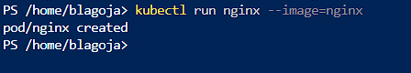

1. Validate if the pods has been created. What is the status of your pod?

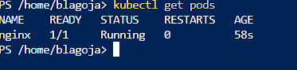

1. **Check the logs coming out of your pod. Run kubectl logs nginx.**

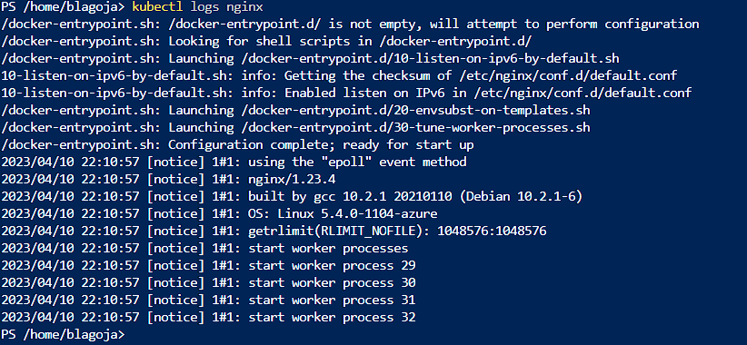

1. **Run following command to check current resource consumption of your pod: kubectl top pod nginx.**

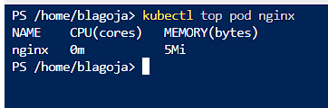

1. **Check on which Node your pods has been scheduled. Run kubectl get pods –o wide.**



1. **Try to find the same information but this time running kubectl describe pod nginx..**

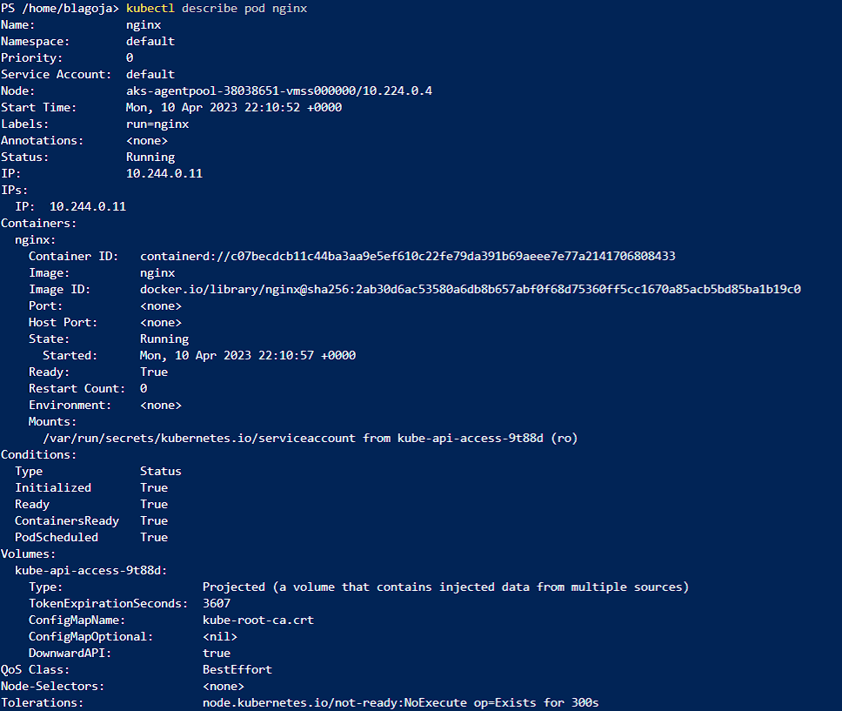

1. **Delete your pod using kubectl delete pod nginx.**



**12. Let’s find the image used on one of the coredns pods under the kube-system namespace.**

**13. Once again list all pods under all namespaces.**

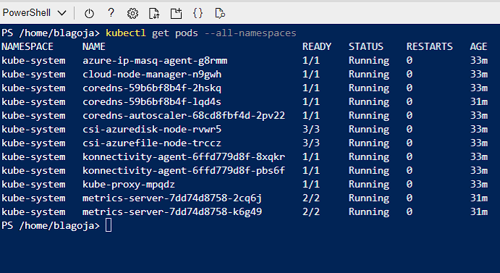

**14. Note one of the coredns pods. Now run kubectl describe pod coredns-59b6bf8b4f-2hskq -n kube-system. Replace the**

**<coredns-name> place holder with noted name.**

**15. Inspect the output and locate the image information.**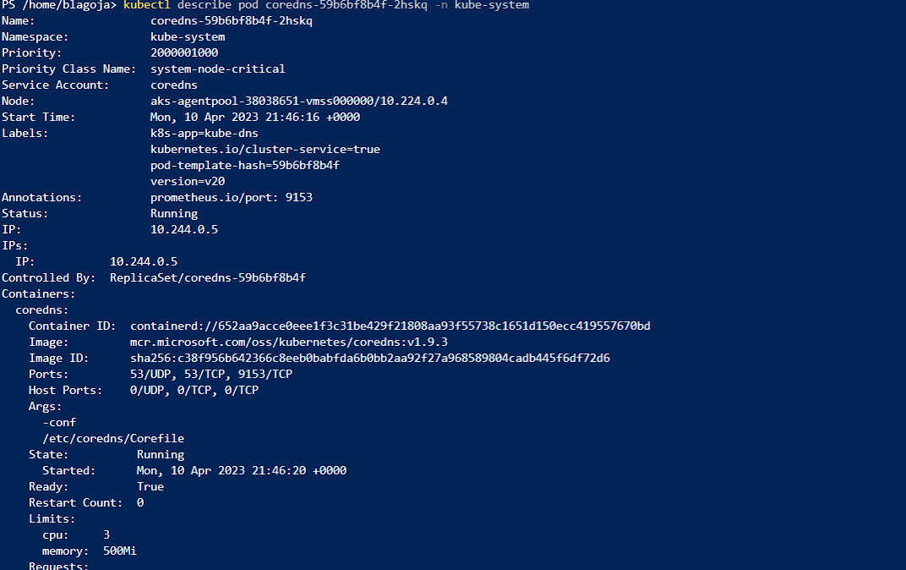

**16. Now let us check the logs of the metrics-server pod. Run the same command as in step 7 but don’t forget to**

**add the namespace in which this pod is created.**

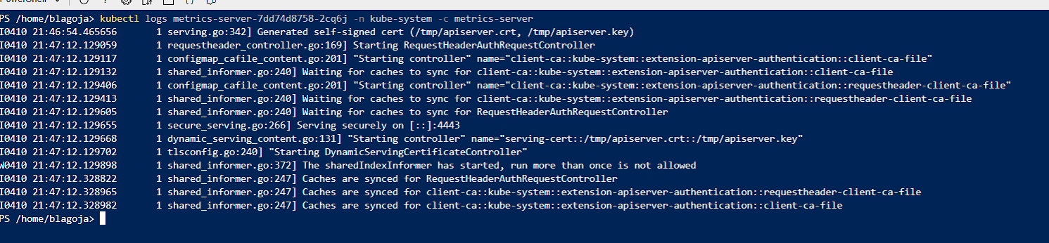

**Practice2: Working with pod manifest files**

**Note: Try not to do a copy/paste on commands requests unless you are instructed to do so.**

**Copy/paste will not help you to learn Kubernetes!**

**1. Now it is time to deploy pod using manifest file (declarative approach). Copy the following code block on your**

**local computer in a file called redis.yaml:**

**...**

**2. Try to deploy the pod defined in redis.yaml. Run kubectl create –f redis.yaml.**

**3. You will receive errors on your screen. Your next task will be to correct the syntax of the code you just**

**copied. You can use the online Kubernetes documentation or you can search the internet in general.**

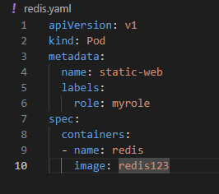

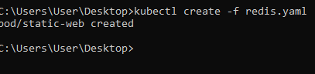

4. When you solve all the syntax errors your pod should be deployed but is it running? What is the status of  
your pod?

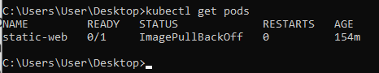  
5. Check the events associated with this pod. Run the kubectl describe pod static-web command. What are the  
events showing? Why your pod is not running?

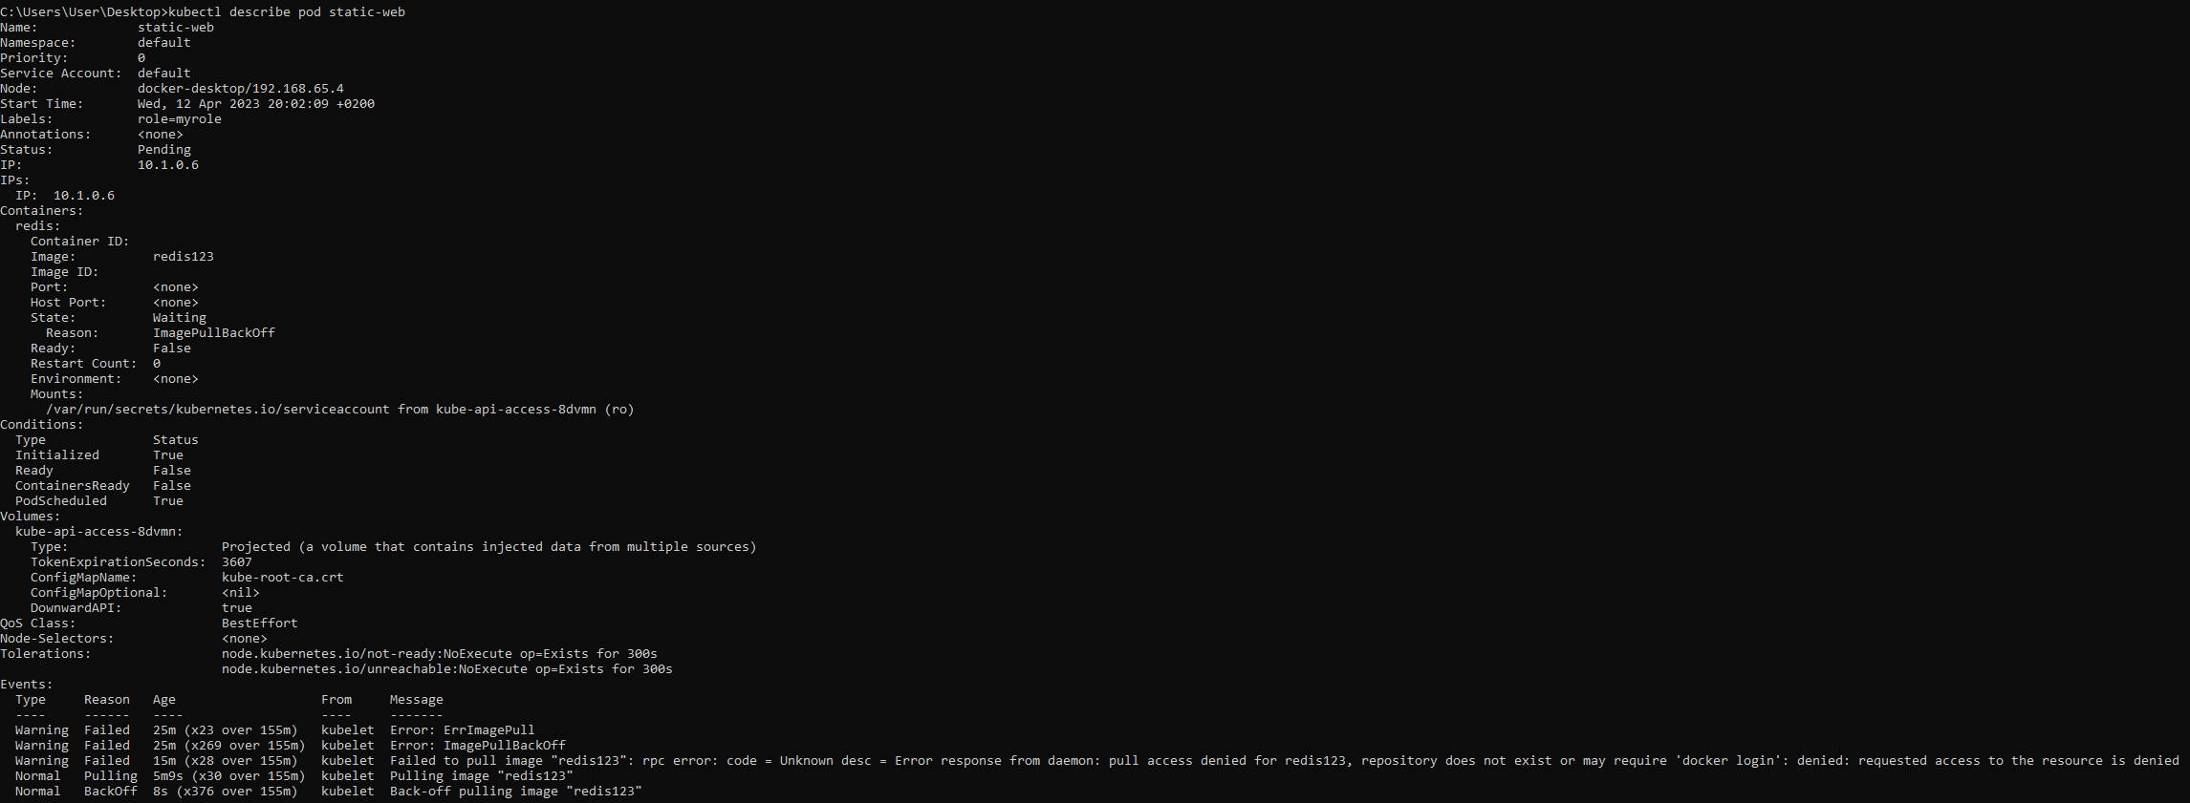

The pod is not running because there is an error indicating that the image redis123 could not be pulled from the specific container registry  
6. Find the correct image (check the Docker hub page) and correct it in the manifest.

7. Locate the image information and put the correct image name. Redeploy the pod (fist run kubectl deletepod static-web to delete the pod, then run kubectl create once again).



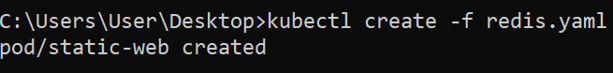

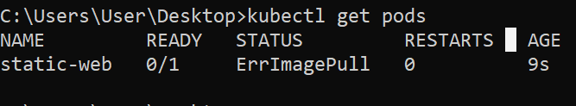  
8. Check the status of your pod. It should be running now.

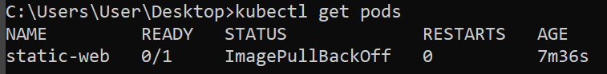  
9. Now you can delete the pod. Try to delete it using the kubectl delete –f redis.yaml.

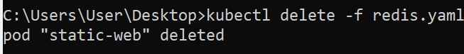  
10. Your next task is to create and test nginx pod definition. Your definition should use the nginx official image,  
should use label named app with value frontend and should publish port 80. Make sure you complete this  
task because we will use this template in our next Labs. Your nginx pod should be running without any issues.

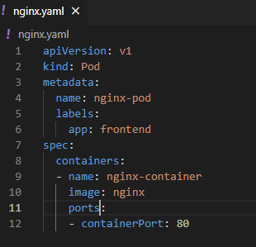

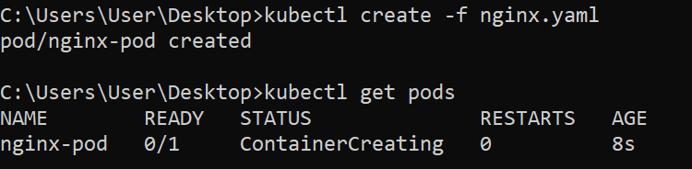

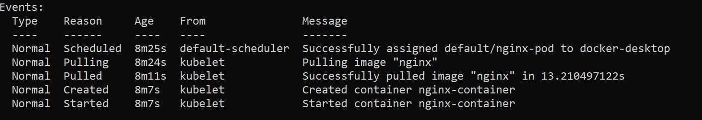

11. Final task of this practice will be to define pod definition with following details:  
- Image=memcached  
- Port= 11211  
- Label app=web   
- CPU request=0.35 cores  
- RAM request=0.15 GB  
- CPU limit=0.5 cores  
- Ram limit=0.25 GB  
- Restart policy=Never

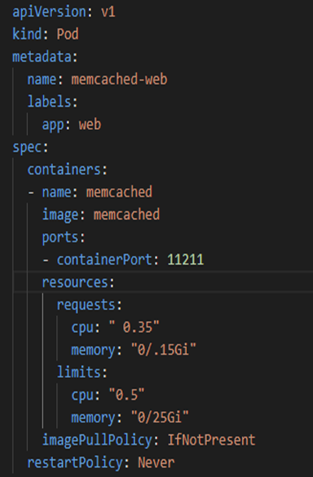  
12. Don’t forget to try your pod definition.

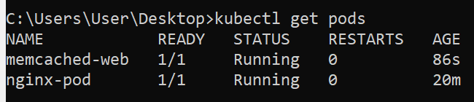

**Practice3: Multi-container pods**

1. Once finished you can try to create multi-container pod definition. Your multi-container pod should use

redis and nginx containers with port 6379 and 80 published respectively. Label name should be app with

value web.

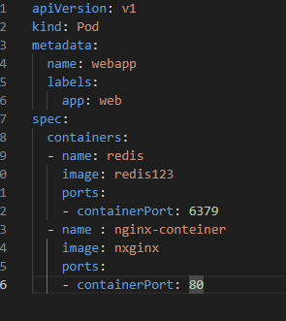

2. Note that in reality there is no sense to put the redis and nginx under the same pod but it can be done

for the purpose of learning.

3. Deploy your multi-container pod. It should have running status. What is written under Ready column

when you kubectl get the pods? Why your pod displays different values for ready?

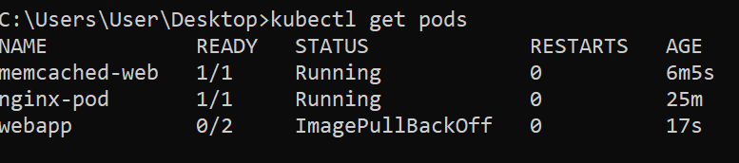

4. Kubectl describe you new pod, and locate the containers section. How many containers are listed?

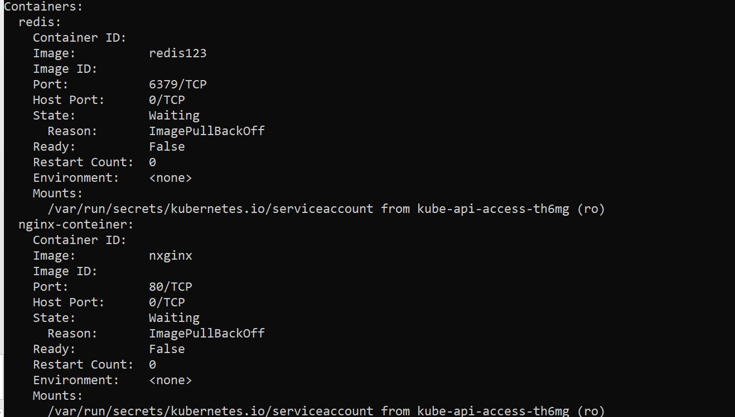

5. Delete all the pods under the default namespace 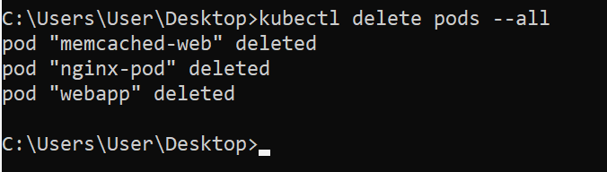

6. Don’t delete any of the manifest files you have created so far.

**Practice4: Probes**

1. First we will create and test liveness probe with exec test. Create a file named probes_exec.yaml with  
following content:

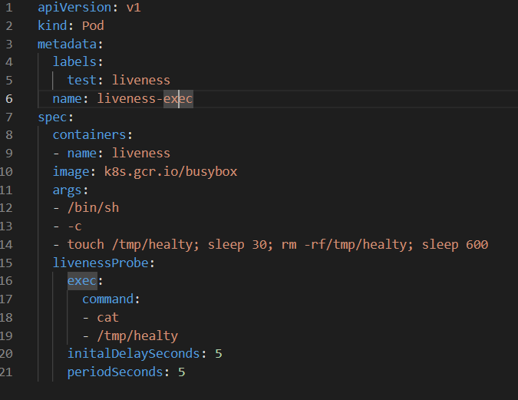

2. Examine the containers args commands especially the line that start with touch. This bash pipeline will  
help us to test the liveness probes.  
3. Run kubectl create –f probes_exec.yaml.



4. Run kubectl describe pod liveness-exec immediately after you deploy the pod. The output should indicate  
that no liveness probes have failed yet.

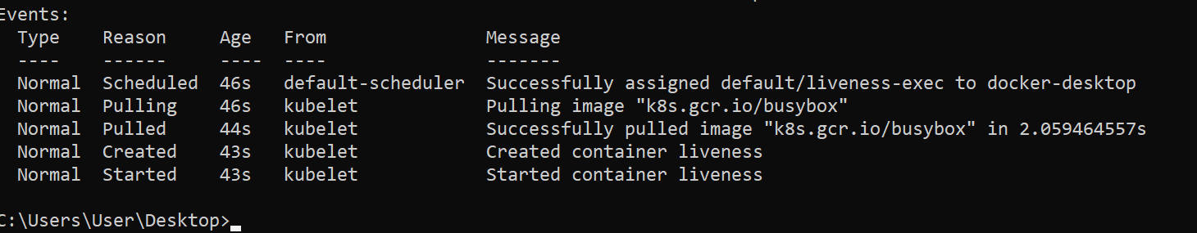  
5. After 35 seconds, view the Pod events again. Run kubectl describe pod liveness-exec.6. At the bottom of the output, there should be a messages indicating that the liveness probes have failed,  
and the containers have been killed and recreated.  
7. Wait another 30 seconds, and verify that the container has been restarted. Run kubectl get pod livenessexec.

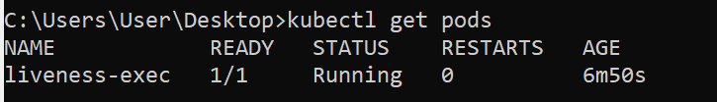8. The output should show that RESTARTS has been incremented.  
9. We will continue with HTTP probe. Create file named probes_http.yaml with following content:

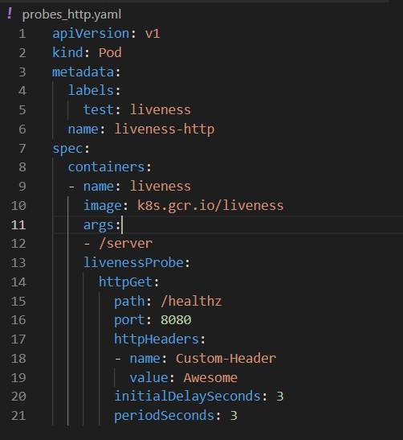

11. For the first 10 seconds that the container is alive, the /healthz handler returns a status of 200. After that,

the handler returns a status of 500.

12. Run kubectl create –f probes_http.yaml.

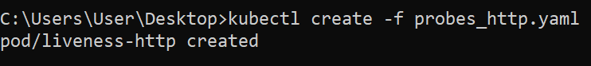

13. Immediately run (you only have 10 secs to run this command) kubectl describe pod liveness-http.

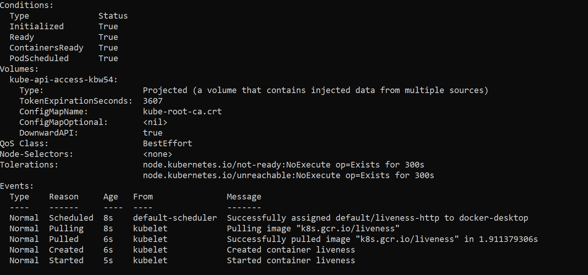

14. Your pod should be live and running.

15. After 10 seconds, view Pod events to verify that liveness probes have failed and the container has been

restarted. Run again kubectl describe pod liveness-http.

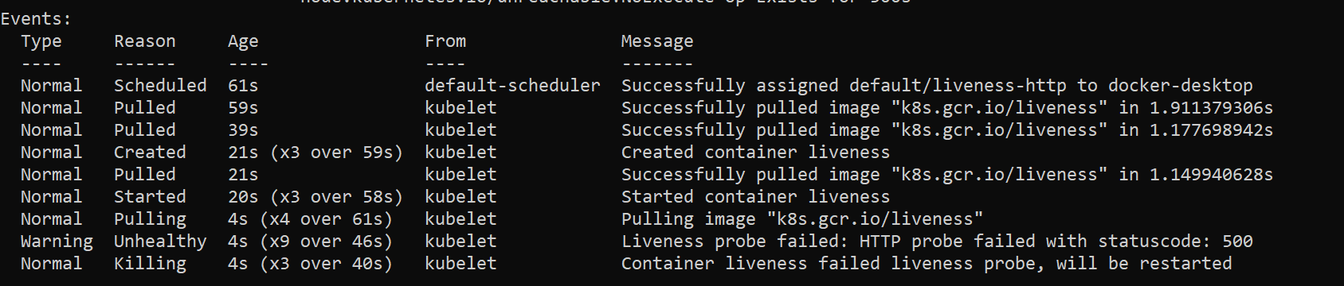

16. You should see the same output as in step 7. Kubelet will reboot he container.KUBE

17. We continue with TCP probes. Create file named probes_tcp.yaml with following content:  
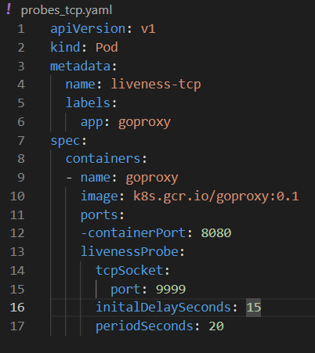

18. Run kubectl create –f probes_tcp.yaml.

19. Immediately run (you only have 10 secs to run this command) kubectl describe pod liveness-tcp.

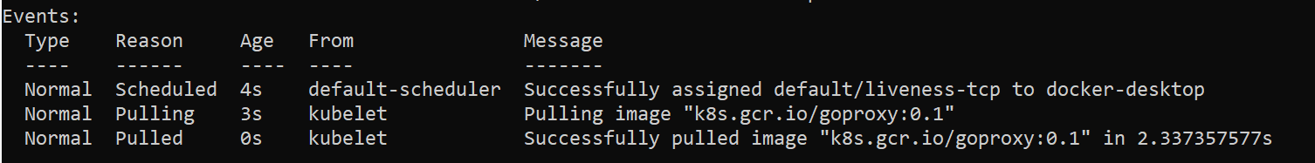20. Your pod should be live and running.  
21. After 10 seconds, view Pod events to verify that liveness probes have failed and the container has been  
restarted. Run again kubectl describe pod liveness-tcp.

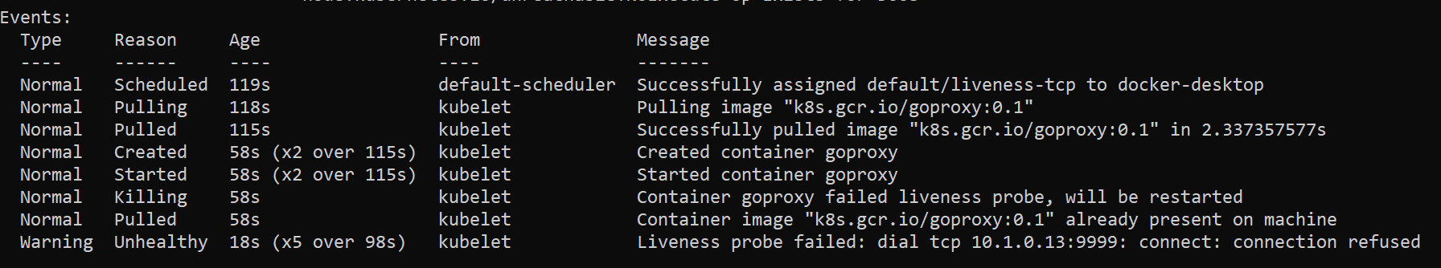22. You should see the same output as in step 7 and 16. Kubelet will reboot he container.  
23. Our last job will be to define one readiness probe using HTTP test.

24. Create file named readiness_http.yaml with following content:

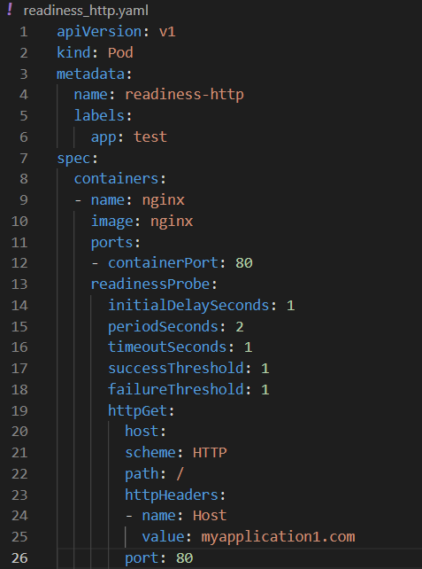

25. Run kubectl create –f readiness_http.yaml.

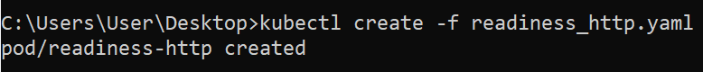  
26. Run kubectl get pods –A to see the status of your pod.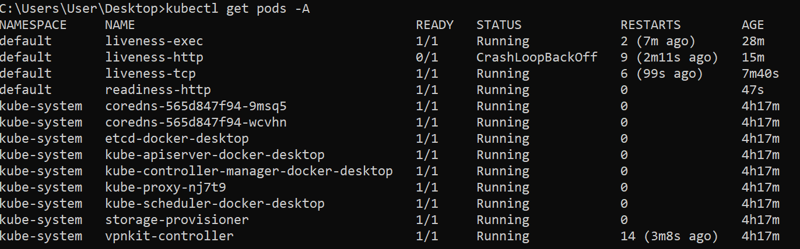

27. Pods and their status and ready states will be displayed; our pod should be in running state.  
28. Run kubectl describe pod readiness-http. Examine the events for this pod. Everything should be OK.

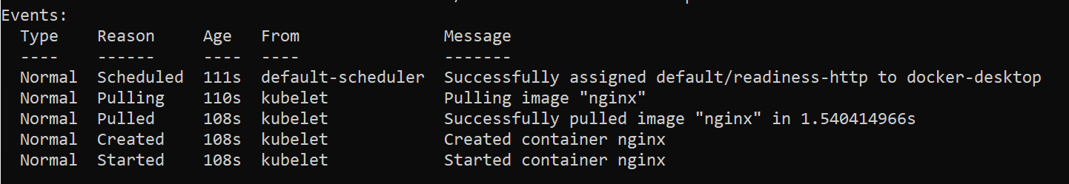  
29. Now delete the pod and edit the readiness_http.yaml so that the port parameter has 81 value.

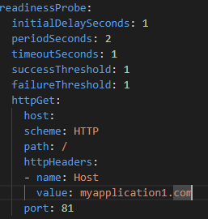

30. Run again kubectl create –f readiness_http.yaml.

31. Run kubectl get pods –A to see the status of your pod. You should see that the pod is running but it is not  
in ready state.

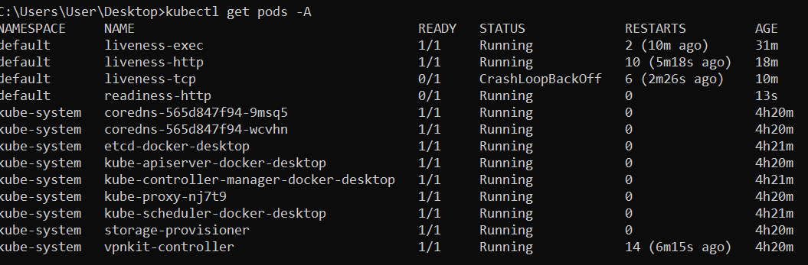  
32. Describe the pod. Run kubectl describe pod readiness-http.

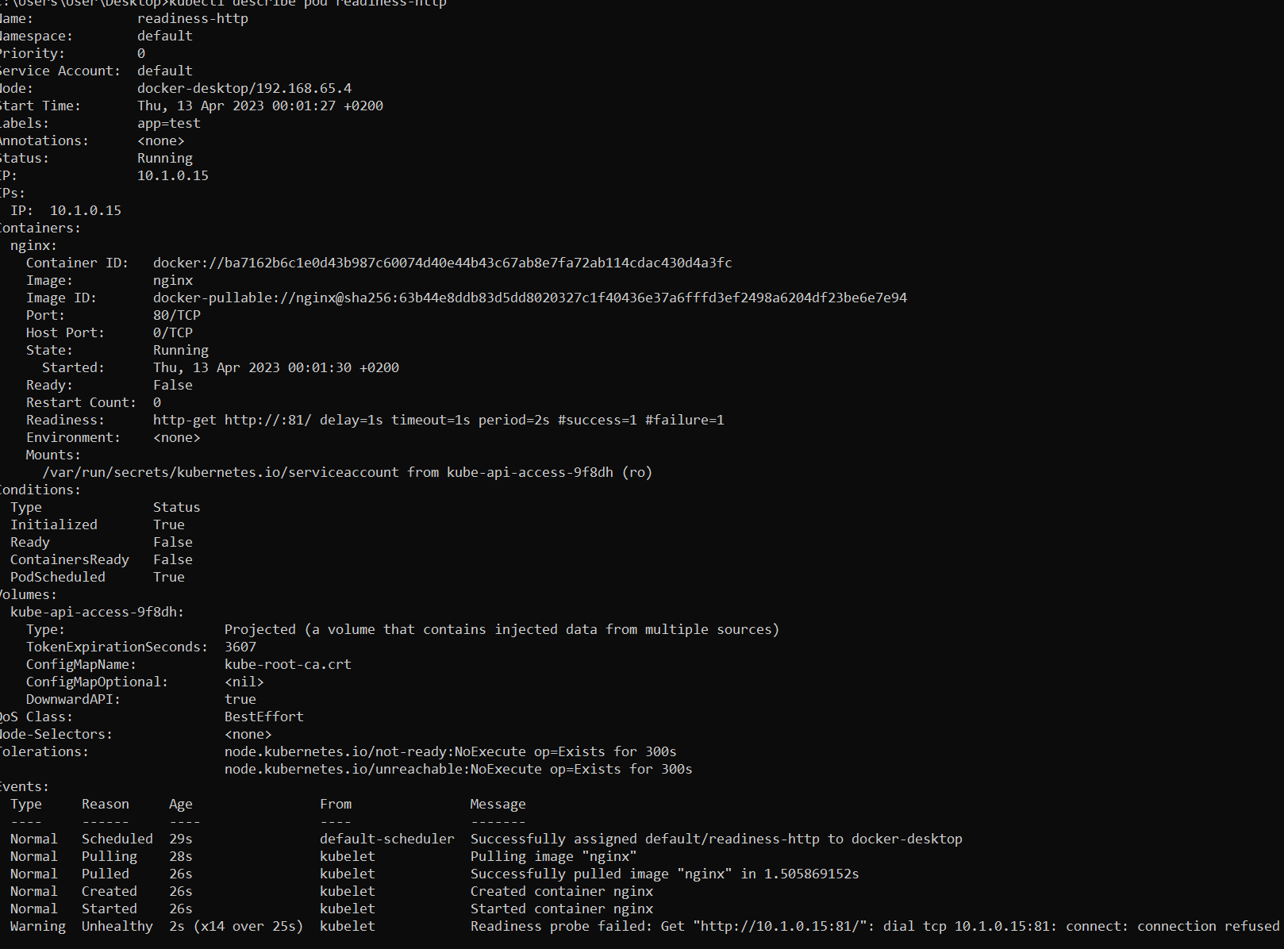33. From the events we can see that readiness probe failed due to the connection being refused therefore  
pod will not receive any traffic.  
34. Delete all pods under the default namespace.

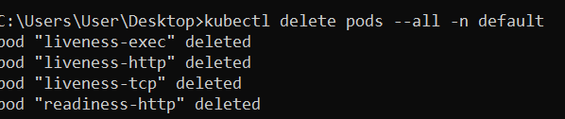  
35. Don’t delete any manifest files created so far